Packet Tracer - Using Traceroute to Discover the Network

1. Topology

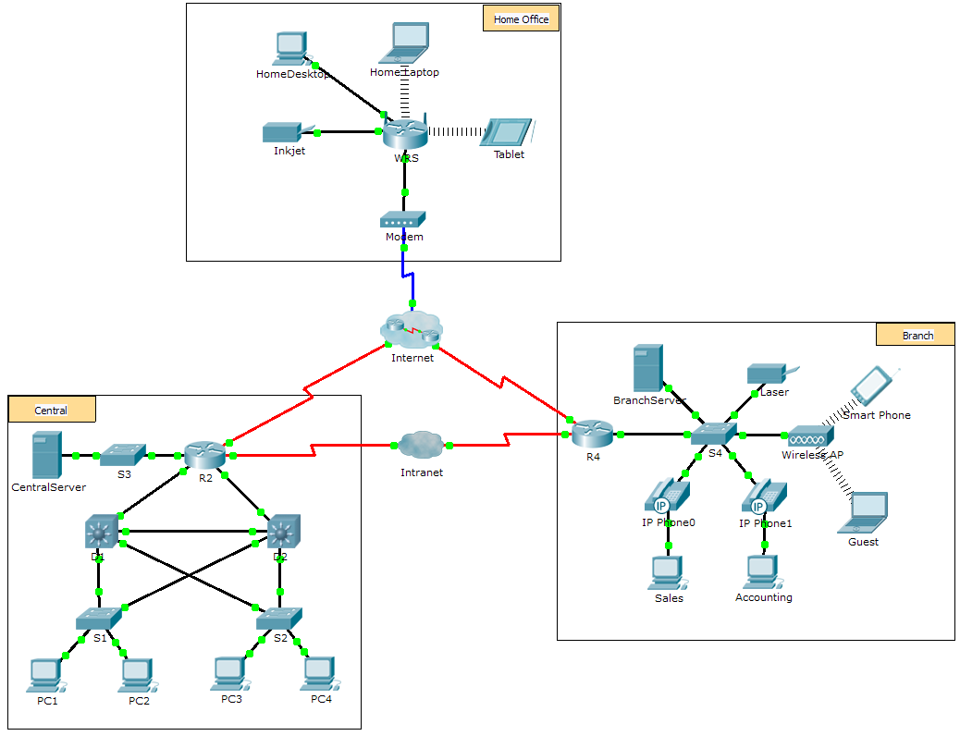

1. Scenario

The company you work for has acquired a new branch location. You asked for a topology map of the new location, but apparently one does not exist. However, you have username and password information for the new branch’s networking devices and you know the web address for the new branch’s server. Therefore, you will verify connectivity and use the **tracert** command to determine the path to the location. You will connect to the edge router of the new location to determine the devices and networks attached. As a part of this process, you will use various show commands to gather the necessary information to finish documenting the IP addressing scheme and create a diagram of the topology.

**Note**: The user EXEC password is **cisco**. The privileged EXEC password is **class**.

1. Trace and Document a Remote Location

**Note:** As you complete the following steps, copy command output into a text file for easy reference and record the missing information in the **Addressing Scheme Documentation** table.

Refer to the **Hints** page for a review of the commands used. In Packet Tracer, click the right arrow (>) on the bottom right side of the instruction window. If you have a printed version of the instructions, the **Hints** page is the last page.

* + 1. Click **Sales** and the **Desktop** tab > **Command Prompt**. Use the **ipconfig** command to check the IP address configuration for **Sales**.
    2. The new server web address is **b2server.pt.pka.** Enter the following **nslookup** command to discover the IP address for **b2server**:

PC> **nslookup b2server.pt.pka**

What address did the command return for **b2server**? ______________________

* + 1. Enter the **tracert** command to determine the path from **Sales** to **b2server.pt.pka**.

PC> **tracert b2server.pt.pka**

* + 1. Telnet to the first IP address in the **tracert** output and log in.

PC> **telnet 172.16.0.1**

* + 1. You are connected to the **R4** router. Issue the **traceroute** command on the router using the address for b2server determined in step b. What is different about the **traceroute** command on the router compared to **tracert** on the PC?

____________________________________________________________________________________

____________________________________________________________________________________

What is the significance of **R4** to **Sales**?

____________________________________________________________________________________

* + 1. Use the **show ip interface brief** command to display the status of the interfaces on **R4**. Based on the output of the command, which interface is used to reach the next device in the list output from the **tracert** command?

_______interface s0/0/0 is connected to the 64.100.150.0 network

_____________________________________________________________________________

Hint: Use **show running-config** to view the subnet mask values for the interfaces.

* + 1. Telnet to the second IP address in the **tracert** list and log in. You can use the number in the far left column of the **tracert** output to track where you are in the list. What is the name of the device to which you are connected? ______________________
    2. Issue the **show ip route** command and study the output. Referring to the list of codes at the beginning of the output, what are the different types of routes displayed in the routing table?

____________________________________________________________________________________

* + 1. Based on the **show ip route** command output, which interface is the exit interface for the next IP address listed in your original **tracert** output? ______________________
    2. Telnet to the third IP address in the **tracert** list and log in. What is the hostname of the current device?

____________________________________________________________________________________

Issue the **show ip route connected** command. What networks are connected directly to this router?

____________________________________________________________________________________

Refer to the **Addressing Scheme Documentation** table. Which interfaces connect the devices between trace route 2 and trace route 3?

____________________________________________________________________________________

* + 1. Telnet to the fourth IP address in the **tracert** list and log in. What is the name of the device?

____________________________________________________________________________________

* + 1. Issue a command to determine to what interface **b2server.pt.pka** is connected

____________________________________________________________________________________

* + 1. If you have used the **Addressing Scheme Documentation** table as you completed the previous steps, the table should now be complete. If not, finish the table now.
    2. With a complete documentation of the addressing scheme and knowledge of the path from **Sales** to **branch2.pt.pka**, you should be able to now draw the new branch location in the **Topology Documentation** space below.

1. Addressing Scheme Documentation

|  |  |  |  |  |
| --- | --- | --- | --- | --- |
| Trace Route ID | Device | Interface | Address | Subnet Mask |
| - | Sales | NIC | 172.16.0.x (DHCP) | 255.255.255.0 |
| 1 | R4 | G0/0 | 172.16.0.1 | 255.255.255.0 |
| G0/1 | N/A | 255.255.255.252 |
| S0/0/1.1 | 64.100.200.1 | 255.255.255.252 |
| 2 | ISP-Tier3a | G0/0 | 64.104.222.1 | 255.255.255.255 |
| G0/1 | 64.104.223.1 | 255.255.255.252 |
| S0/0/0 | 64.100.100.2 | 255.255.255.255 |
| S0/1/0 | 64.100.150.2 | 255.255.255.255 |
| 3 | ISP-Tier3b | G0/1 | 64.104.222.2 | 255.255.255.255 |
| G0/2 | 64.100.8.1 | 255.255.255.0 |
| F0/1 | 128.107.46.1 | 255.255.255.0 |
| F0/2 | 64.104.222.5 | 255.255.255.255 |
| 4 | B2-R1 | G0/0 | 64.104.222.6 | 255.255.255.255 |
| G0/1 | 128.107.64.1 | 255.255.255.0 |
| 5 | b2server.pt.pka | NIC | 128.107.64.254 | 255.255.255.0 |

1. Topology Documentation

Use the space below to draw the topology for the new branch location.

1. Suggested Scoring Rubric

|  |  |  |
| --- | --- | --- |
| Activity Section | Possible Points | Earned Points |
| Questions (2 points each) | 20 |  |
| Addressing Scheme Documentation | 60 |  |
| Topology Documentation | 20 |  |
| **Total Point** | **100** |  |

1. Hints - Command Summary Reference
2. DOS Commands

**ipconfig** - The output of the default command contains the IP address, network mask and gateway for all physical and virtual network adapters.

**ipconfig /all** - This option displays the same IP addressing information for each adapter as the default option. Additionally, it displays DNS and WINS settings for each adapter.

**Nslookup** - Displays information that you can use to diagnose Domain Name System (DNS) infrastructure.

Syntax:

nslookup dns.name

**Tracert** - Determines the path taken to a destination by sending Internet Control Message Protocol (ICMP) Echo Request messages to the destination with incrementally increasing Time to Live (TTL) field values. The path displayed is the list of near-side router interfaces of the routers in the path between a source host and a destination. The near-side interface is the interface of the router that is closest to the sending host in the path. Used without parameters, tracert displays help.

Syntax:

tracert [TargetName/IP Address]

1. IOS Commands

**show ip interface** – Displays the IP interface status and configuration

**show ip interface brief** – Displays a brief summary of IP status and configuration

**show ip route** – Displays the full IP routing table

**show ip route connected** – Displays a list of active directly connected networks

**show running-config** – Displays the current operating configuration

**traceroute** – Trace route to destination